|  |
| --- |
| Circle Language Spec: Black Boxes |

## Assignment between Friend Members

A connection or assignment always involves two objects. In a connection or assignment that involves a friend object, the access mark is a wavy line. It is only clear which of the objects are friend-accessed from the friend access *connectors*.

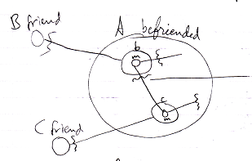

In the example above both members involved in the connection are friend. It is only clear which objects in the access are friend from the presence or absence of a friend access *connector*.

In the following example, one of the members is public while the other one is private.

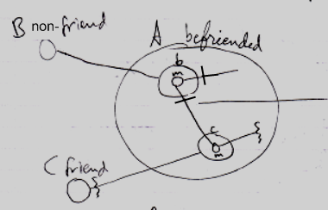

Member m of reference **b** is Get-public. The access mark of the connection is changed to a Public access mark, because the Get-access is public, and an access mark expresses the Get-access. To see which member involved in a connection or assignment is friend, you should look at the *access connectors* and not necessarily at the access mark on the connection or assignment call.